**Accuracy Analysis**

**Data Processing**

Each participant's accuracy was calculated by comparing the total amount of numbers displayed with the correct numbers they identified. Omissions were treated as errors, thus affecting the overall accuracy scores.

**Calculation of Individual Accuracies**

Individual accuracies were computed for each participant across three conditions: easy (3 digits), medium (5 digits), and hard (8 digits). This data was then compiled to assess performance variations based on the task difficulty.

|  |  |  |
| --- | --- | --- |
| **Participant** | **Condition (Digits)** | **Accuracy (%)** |
| P1 | Easy (3 digits) | 73.33 |
| P1 | Medium (5 digits) | 60 |
| P1 | Hard (8 digits) | 61.54 |
| P2 | Easy (3 digits) | 86.67 |
| P2 | Medium (5 digits) | 60 |
| P2 | Hard (8 digits) | 62.96 |
| P3 | Easy (3 digits) | 0 |
| P3 | Medium (5 digits) | 0 |
| P3 | Hard (8 digits) | 0 |
| P4 | Easy (3 digits) | 83.33 |
| P4 | Medium (5 digits) | 50 |
| P4 | Hard (8 digits) | 20.51 |
| P5 | Easy (3 digits) | 0 |
| P5 | Medium (5 digits) | 0 |
| P5 | Hard (8 digits) | 0 |
| P6 | Easy (3 digits) | 86.67 |
| P6 | Medium (5 digits) | 84.44 |
| P6 | Hard (8 digits) | 98.22 |

**Overall Performance Metrics**

Here, we computed the mean and standard deviation of accuracies across all participants for each condition. The results are as follows:

* **Easy Condition**: Average accuracy was approximately 58.89% with a high standard deviation of 46.46%, indicating significant variability in participant performance.
* **Medium Condition**: Average accuracy decreased to around 45.64% with a standard deviation of 38.99%, reflecting increased task difficulty.
* **Hard Condition**: Average accuracy further dropped to 28.21%, with a standard deviation of 42.60%, showcasing substantial challenges faced by participants in the hardest setting.

**Visualization**

A bar chart was created to illustrate the average accuracies for each condition, with error bars representing the standard deviations.

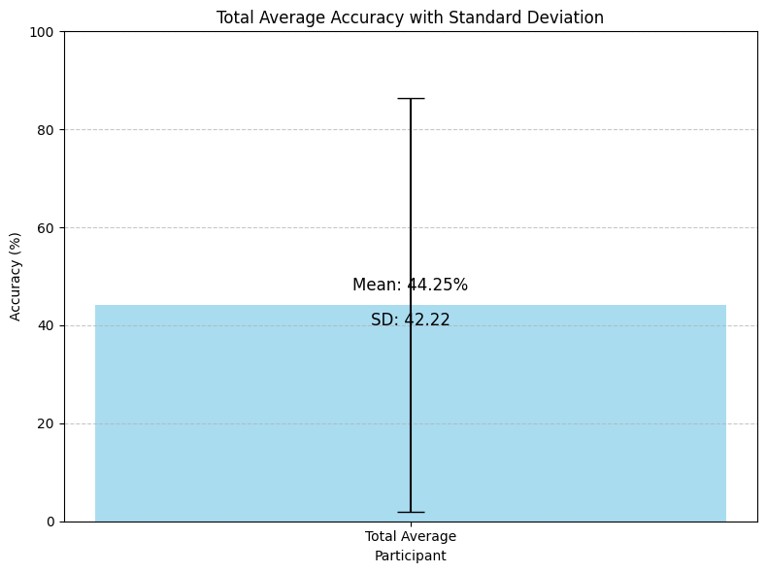

**Overall Accuracy of Each Participant**

The overall accuracy for each participant was calculated across all conditions. The results are as follows:

|  |  |
| --- | --- |
| **Participant** | **Overall Accuracy (%)** |
| P1 | 64.96 |
| P2 | 51.45 |
| P3 | 0 |
| P4 | 51.28 |
| P5 | 0 |
| P6 | 97.78 |

**Observation**

The total average accuracy of 44.25% across all participants and digit sequence lengths (3, 5, and 8 digits) highlights the overall performance of the transcription or recognition process. This metric indicates the general level of correctness achieved. The relatively modest average suggests that there is substantial room for improvement in the data processing methodologies, potentially leading to more accurate and reliable outcomes.

**Count the blinks of each participant in each condition**

We'll start by examining the provided blink rate data for each participant under the three conditions: easy, medium, and hard.

|  |  |  |
| --- | --- | --- |
| participant | Blink rate | condition |
| p1 | 57 | easy |
| p1 | 264 | easy |
| p1 | 75 | medium |
| p1 | 212 | medium |
| p1 | 43 | hard |
| p1 | 211 | hard |
| p2 | 40 | easy |
| p2 | 596 | easy |
| p2 | 552 | medium |
| p2 | 41 | hard |
| p2 | 574 | hard |
| p3 | 32 | easy |
| p3 | 508 | easy |
| p3 | 517 | medium |
| p3 | 517 | hard |
| p4 | 678 | easy |
| p4 | 117 | easy |
| p4 | 409 | medium |
| p4 | 38 | hard |
| p4 | 547 | hard |
| p5 | 580 | easy |
| p5 | 88 | easy |
| p5 | 366 | medium |
| p5 | 62 | hard |
| p5 | 682 | hard |
| p6 | 17 | easy |
| p6 | 858 | easy |
| p6 | 725 | medium |
| p6 | 329 | hard |

**Overall Performance Metrics for Blink Rates**

**Data Summary:** The dataset represents the average blink rates for each participant across three conditions: easy, medium, and hard. These averages were calculated based on the number of blinks recorded during tasks of varying digit counts, which were classified into the three conditions based on their complexity.

|  |  |  |
| --- | --- | --- |
| participant | condition | average blink rate |
| p1 | easy | 160.5 |
| p1 | medium | 143.5 |
| p1 | hard | 127 |
| p2 | easy | 318 |
| p2 | medium | 552 |
| p2 | hard | 307.5 |
| p3 | easy | 270 |
| p3 | medium | 517 |
| p3 | hard | 517 |
| p4 | easy | 397.5 |
| p4 | medium | 409 |
| p4 | hard | 292.5 |
| p5 | easy | 334 |
| p5 | medium | 366 |
| p5 | hard | 372 |
| p6 | easy | 437.5 |
| p6 | medium | 725 |
| p6 | hard | 329 |

**Observations**

Across all participants, we observe an increase in blink rates as the tasks increase in complexity from easy to medium but a varied response from medium to hard. This inconsistency might suggest that while the medium tasks require more cognitive effort compared to easy tasks, the hardest tasks might involve a level where the cognitive load stabilizes or involves different strategies that do not linearly increase blink rates.

